**EXPERT SYSTEMS**

* One of the largest area of applications of artificial intelligence is in expert sytems, or knowledge based systems as they are often known. This type of system seeks to exploit the specialised skills or information held by of a group of people on specific areas.
* It can be thought of as a computerized consulting service. It can also be called an information guidance system. Such systems are used for prospecting medical diagnosis or as educational aids.
* They are also used in engineering and manufacture in the control of robots where they inter-relate with vision systems..

**STRUCTURE**

The internal structure of an expert system can be considered to consist of three parts:

the knowledge base ; the database; the rule interpreter.

the set of productions; the set of facts held as working memory and a rule interpreter.

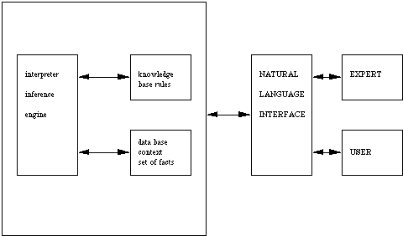

The knowledge base holds the set of rules of inference that are used in reasoning. Most of these systems use IF-THEN rules to represent knowledge.

The database gives the context of the problem domain and is generally considered to be a set of useful facts.

The rule interpreter is often known as an inference engine and controls the knowledge base using the set of facts to produce even more facts.

**OPERATION OF THE SYSTEM**

Again there are three modes to this:

the knowledge acquisition mode;

the consultation mode;

and the explanation mode.

We shall consider each in turn.

**KNOWLEDGE ACQUISITION**

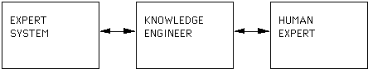

The following example is hypothetical but illustrates the action of typical systems.

**System:** What is the patient's name?

**User:**George Washington

**System:**What is the patient's age?

**User:**252 years

**System:**Is the patient male or female?

**User:**Male

**System:**What are the symptoms?

**User:**Headache dizziness upset stomach high fever

**System:**When did these symptoms first appear?

**User:**December 13,1799

**System:**I conclude that the patient has a viral infection , my recommendation is that he should take two aspirin, drink plenty of fluid, get lots of rest and call me in the morning.

George Washington died the next day of a viral infection no antibiotics

EXPLANATION

This mode allows the system to explain its conclusions and its reasoning process. This ability comes from the AND/OR trees created during the production system reasoning process. As a result most expert systems can answer the following why and how questions

**why was a given fact used?**

**why was a given fact not used?**

**how was a given conclusion reached?**

**how was it that another conclusion was not reached?**

Let us illustrate the action of an expert system by considering the behaviour of an actual one MYCIN a medical expert system.

Mycin has been informed that a patient has contracted meningitis while in hospital. Doctors wish to interrogate Mycin to check this diagnosis.